Reading Comprehension:
Copyright © 2017 Education.com LLC All Rights Reserved More worksheets at www.education.com/worksheets

Find worksheets, games, lessons & more at education.com/resources
© 2007 - 2020 Education.com
The Serpent and the Eagle
Name: Date:

Read the fable and answer the questions that follow

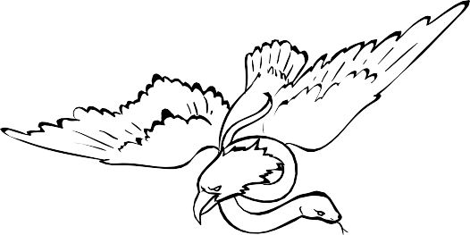
An Eagle swooped down upon a Serpent and seized it in his talons with the intention⁵ of carrying it off and devouring⁶ it. But the Serpent was too quick for him and had its coils round him in a moment; and then there ensued a life-and-death struggle between the two. A countryman, who was a witness of the encounter, came to the assistance of the eagle, and succeeded in freeing him from the Serpent and enabling him to escape. In revenge, the Serpent spat some of his poison into the man's drinking-horn.
Heated with his exertions⁷, the man was about to slake his thirst with a draught⁸ from the horn, when the Eagle knocked
it out of his hand, and spilled its contents upon the ground.

- Why did the Eagle swoop down on the Serpent?

- Why did the Eagle knock the drink out of the countryman’s hand?

- How did the countryman help the Eagle?

- What did the Serpent do to punish the countryman?

- What does the picture show?

⁵intention: goal ⁶devouring: swallowing ⁷exertions: hard work ⁸draught: drink

